HIGHMARK CHARTER SCHOOL
DR. SEUSS WEEK
March 2, 2020 – March 6, 2020
Monday, March 2
Cat in the Hat Day – wear stripes
Tuesday, March 3
Fox and Sox Day – wear crazy socks
Wednesday, March 4
Wacky Wednesday – wear mismatched/backwards clothes
Thursday, March 5
Green Eggs and Ham Day – wear green
Friday, March 6
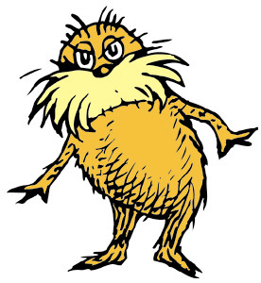
Oh the Places You’ll Go – wear a location shirt, i.e. Yellowstone, Jackson Hole, Paris

