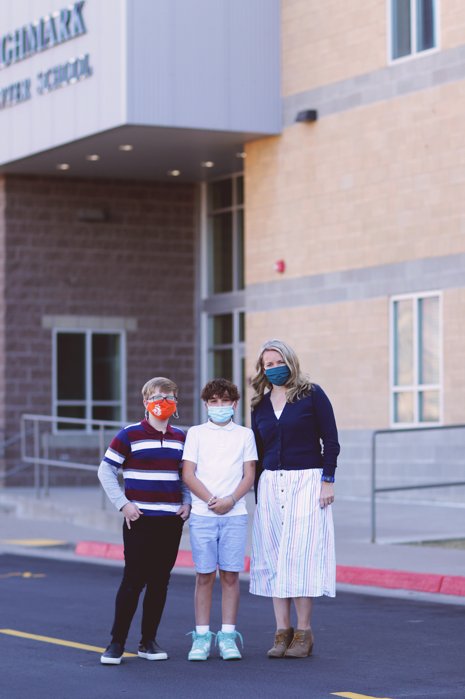

Business  Integration  2nd Quarter | 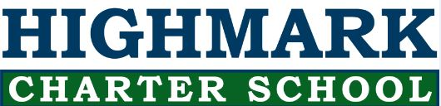 | Our 6th grade SEM class participated in The Stock Market Game. This year was a great year to learn about how current events, elections and many other things contribute to the ups and downs of the market. We had a team of boys take 3rd place in the state, they made $16,000 over the course of 10 weeks.
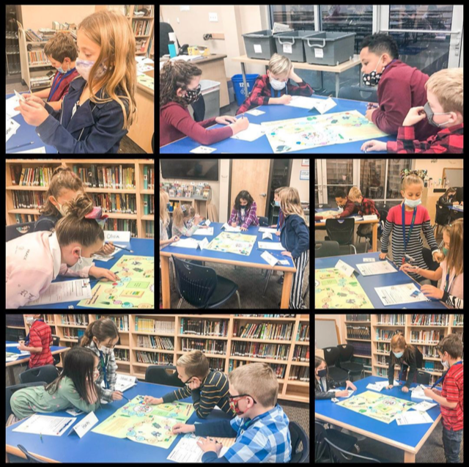  JA lesson with Ms. Camille | Junior Achievement  Ms. Camille has completed our Junior Acheivement lessons in elementary and the kids loved these business and real world lessons.
Winter Carnival Featuring HighMarket  We have completed our Mock HighMarket Online Shopping Week. Students 4th – 9th grade had $20.00 (fake money) to spend on HighMarket Businesses. Our 8th graders are now going through the data and working on their Entrepreneurial Fair. They are figuring out if the had a profit or loss and how popular their business was. | November Leaders of  the MOnth  Habit 3-Put First Things First  *1st Grade – Leo W, Randy L  *2nd Grade – Sakura M, Lyza U  *3rd Grade – Jarron D, Aubrey H  *4th Grade – Henry R, Ana H  *5th Grade – Dade L, Lauren T  *6th Grade – Abigail S, Colby R, Jack S  * Natalia D-LA *Declan M-Health *Cami D-Math *Elle T-History *Emma B-FACS *Mavi S-Speech/Debate *Andrew S-Art ii
* 7th Grade Science: 7th grade is learning about the rock cycle, and Mrs. Mecham had a discussion about the gravel pit across the street. Part of the discussion was how the pit is the largest revenue for the company and is the largest tax base for the city of South Weber.
*In Sociology students learned about micro-targeting and how what you watch determines what commercials you see.
*2nd grade read a story on EPIC and then created Billboard advertisement for the book.
*4th grade learned how to fill out job applications; they were appllying to be an Elf working for Santa.
Some fun examples of Business Integration in the classroom 2nd Quarter

Our 9th graders have begun volunteering at Gigi’s Playhouse in Layton. This is a non-profit facility for people with down syndrom or special needs. Each 9th grade advisory class will have the opportunity to volunteer. We are also helping Giig’s with an Art Collaboration. Our students are drawing pictures for Gigi’s participants to paint,color,etc. and they will be sold at an auction to raise money for Gigi’s Playhouse in Mach 2021. | 